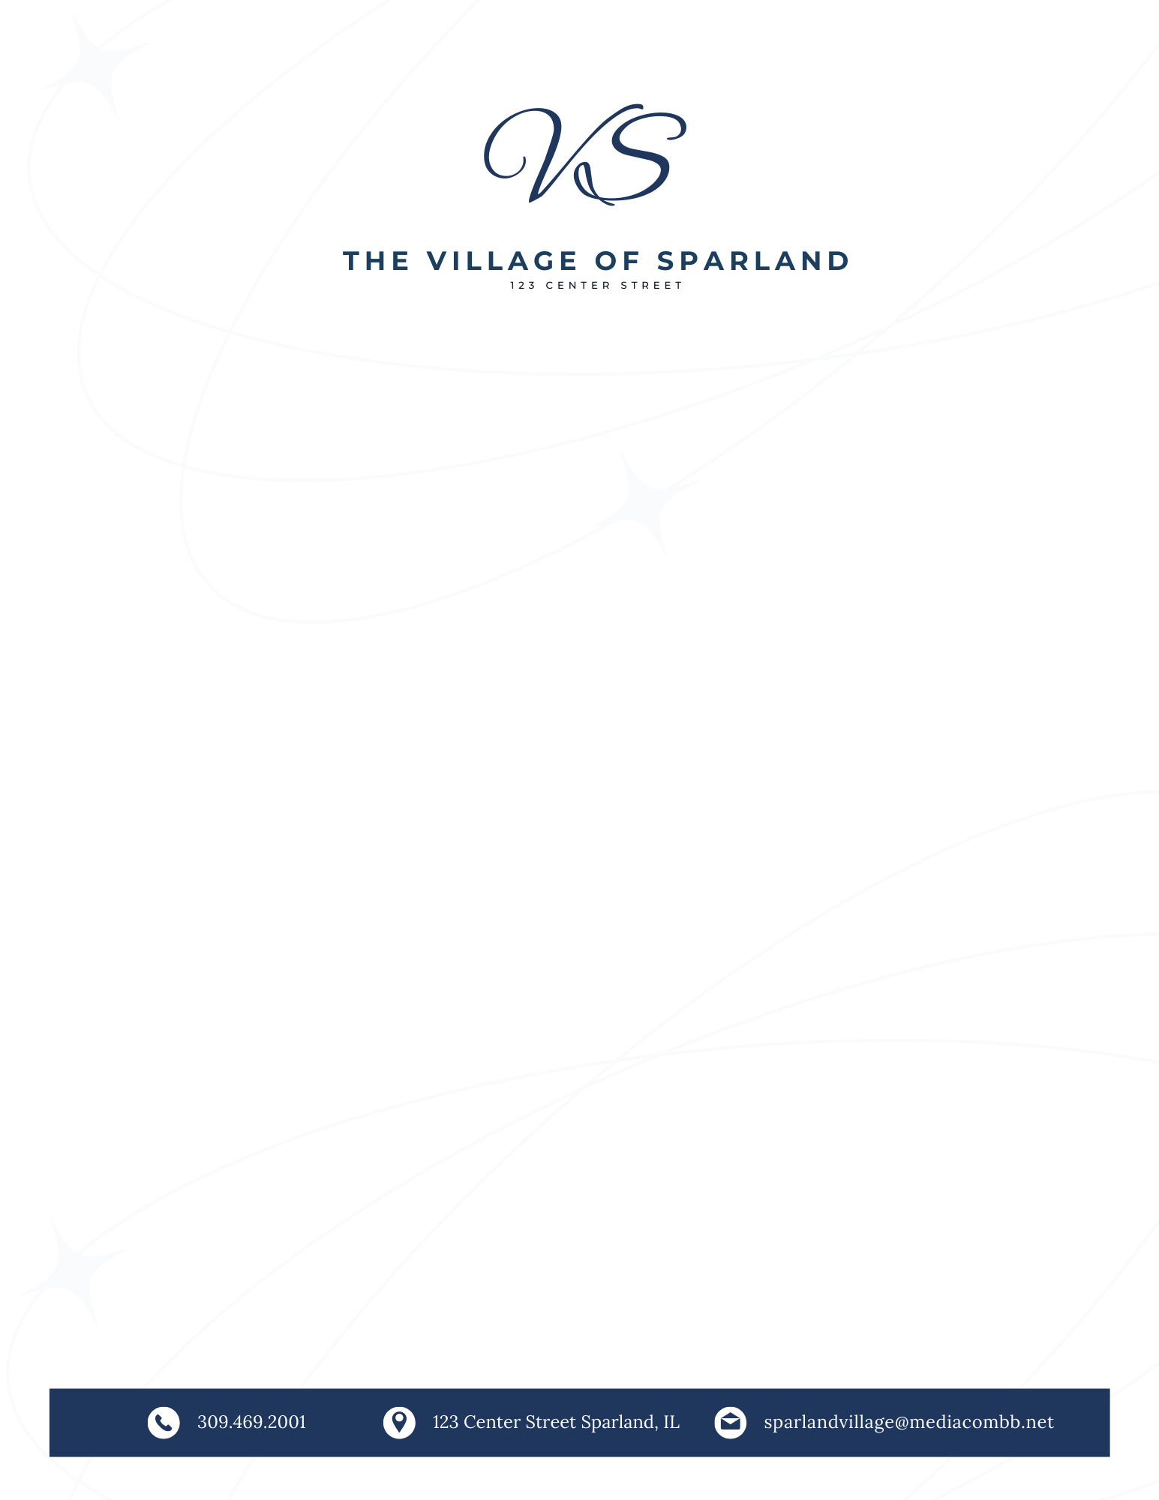

**Thursday the 12th of December 2024**

**123 Center Street**

**Sparland, Il 61565**

**Special Meeting Agenda**

1. **CALL TO ORDER**
2. **PLEDGE OF ALLEGIANCE**
3. **ROLL CALL OF OFFICERS**
4. **DISCUSS 2025 TAX LEVY**
5. **PUBLIC COMMENTS**
6. **NEW BUSINESS**
7. **OLD BUSINESS**
8. **ADJOURNMENT**